Telecom Customer Churn Analysis: Graph Insights & Business Suggestions

1.Churn by Internet Service Type
- Insight: DSL has the highest number of non-churned customers (around 2000) with about 500 churned. Fiber Optic has around 1750 non-churned and 1300 churned. No internet service has about 1500 non-churned and only 100 churned.
- Explanation: DSL customers mostly stay, showing high satisfaction. Fiber Optic has a significant churn (around 40% of total), suggesting issues like cost or service quality. No internet service has very low churn, indicating stability among these customers.
- Suggestion: Improve Fiber Optic service (e.g., fix outages, adjust pricing) to reduce churn. Maintain No internet service quality and offer incentives to keep DSL customers happy.

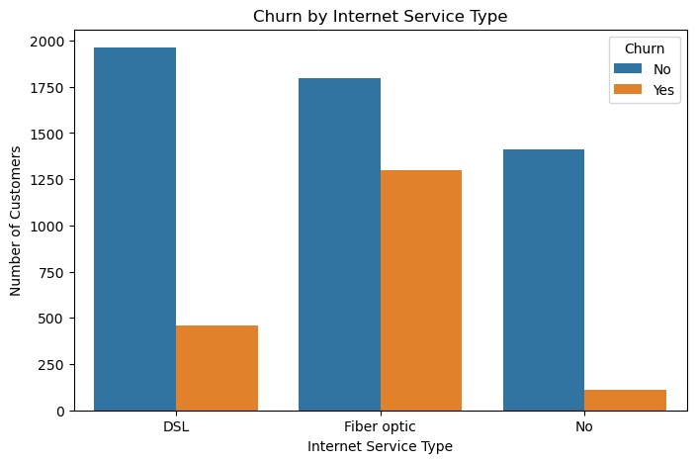

2. Monthly Charges by Internet Service Type and Churn
- Graph Type: Box Plot
- Insight:
  - Fiber Optic churners pay more ($80).
  - DSL and No Internet users show smaller charge differences.

- Explanation:
  - Higher bills are a churn driver, especially in Fiber plans.
- Suggestions:
  - Offer better pricing/bundles for Fiber users.
Promote DSL and basic options as affordable and stable

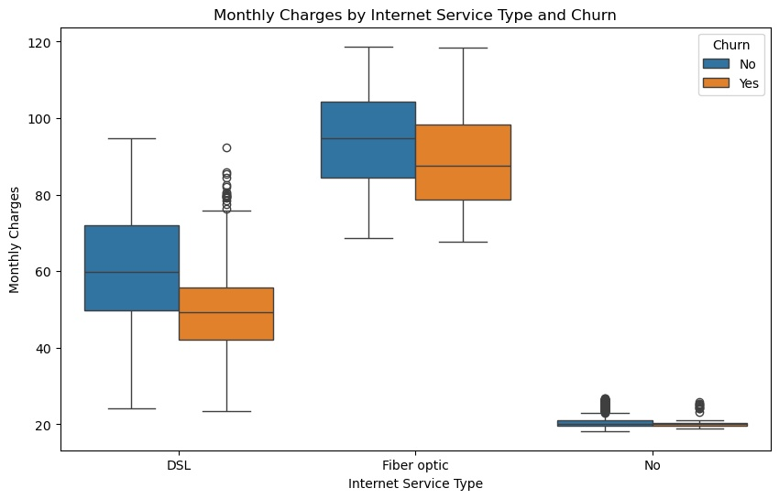

3 Churn Rate by Subscription Plan and Internet Service Type
- Insight: Month-to-Month with Fiber Optic has the highest churn (0.55). Two Year with No internet has the lowest (0.01)

- Explanation: Short plans with Fiber Optic lead to more leaving due to cost or issues. Long plans keep customers better, especially with No internet.
- Suggestion: Fix Fiber Optic problems, offer discounts for Two Year plans, and add value to DSL

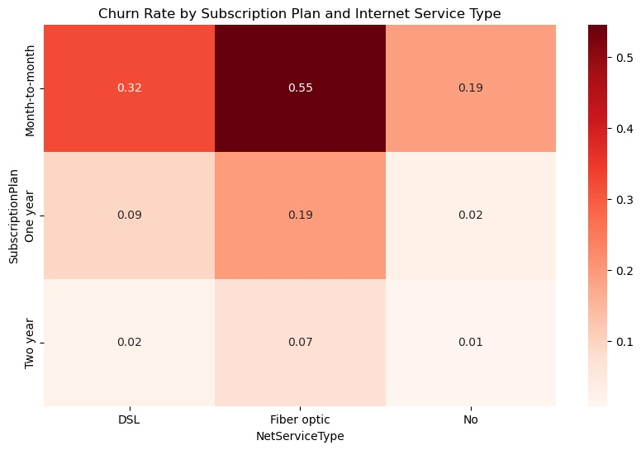
.

4.Churn Trend by Tenure Group
- Insight: Churn rate starts high at 0.45 for the 0-1 year group, drops to 0.30 for 1-2 years, 0.25 for 2-3 years, 0.20 for 3-4 years, 0.15 for 4-5 years, and reaches 0.05 for 5+ years.
- Explanation: New customers (0-1 year) are most likely to leave, possibly due to dissatisfaction or unmet expectations. Churn decreases steadily as tenure increases, showing that longer-term customers are more likely to stay, likely due to loyalty or better service fit.
- Suggestion: Focus on improving the first-year experience with better onboarding or support. Offer incentives like discounts or rewards to retain customers beyond the initial year.
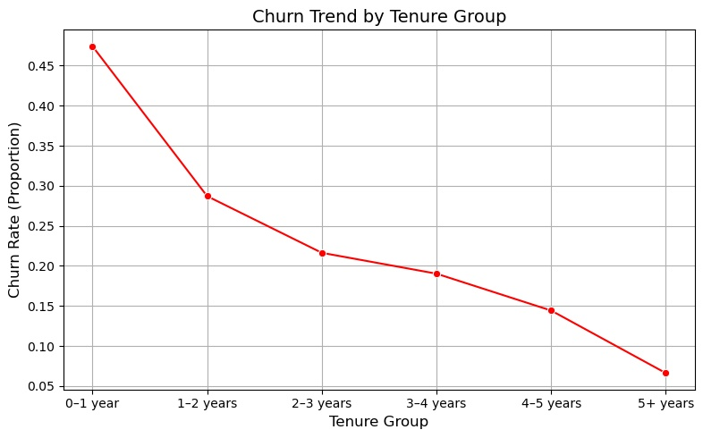
5.Churn by Gender (Non-Seniors, 5+ Years)
- Insight: Both males and females have a high number of non-churned customers (around 500 each), with a small number of churned customers (around 50 for males, slightly less for females).
- Explanation: After 5+ years, most non-senior customers (both male and female) stay, indicating strong loyalty. The low churn (around 10% of total customers) suggests that gender has little impact on leaving after this tenure.
- Suggestion: Maintain loyalty programs or perks for long-term customers (both genders) to keep the low churn rate. Focus on understanding the small number of churned customers to address any specific issues.
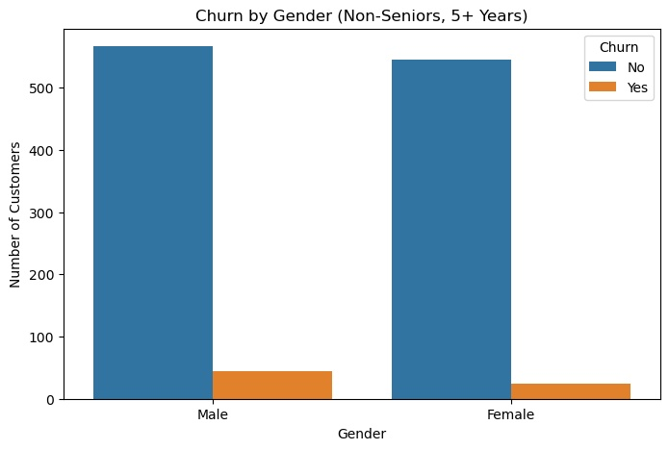

6.Subscription Plan by Gender (Non-Seniors, 5+ Years)
- Insight: The Two Year plan has the highest number of customers (around 400 males, 350 females), the One Year plan has around 150 males and 120 females, and the Month-to-Month plan has the fewest (around 50 males, 30 females).
- Explanation: Long-term plans (Two Year and One Year) are more popular among non-senior customers after 5+ years, with males slightly outnumbering females. Month-to-Month plans are least common, suggesting less interest in short-term flexibility among long-tenured customers.
- Suggestion: Promote Two Year plans with rewards or discounts for both genders to maintain high retention. Offer incentives to shift One Year customers to Two Year plans, and improve Month-to-Month value to attract more users.

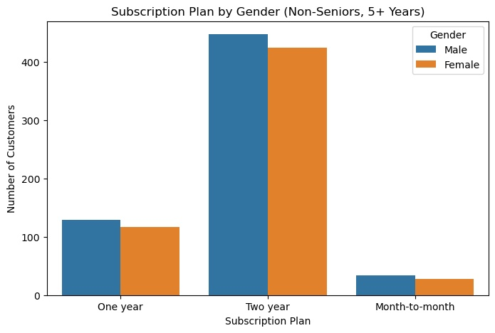

7.Internet Service Type by Gender (Non-Seniors, 5+ Years)
- Insight: DSL has around 250 males and 200 females. Fiber Optic has around 250 males and 225 females. No internet service has about 125 males and 120 females.
- Explanation: DSL and Fiber Optic are more popular among both genders, with males slightly outnumbering females. No internet service has fewer customers, with a balanced gender split, indicating less preference for this option after 5+ years.
- Suggestion: Promote DSL and Fiber Optic with gender-specific offers to maintain high usage. Enhance No internet service value (e.g., add features) to attract more long-term customers.

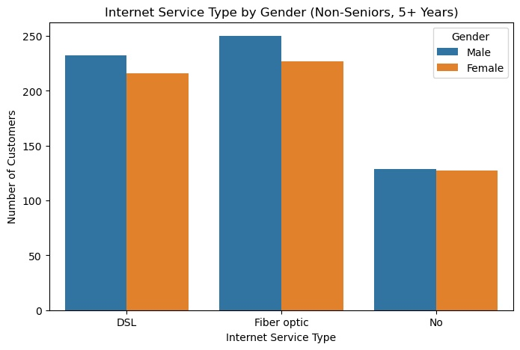
8.Monthly Charges by Gender and Churn (Non-Seniors, 5+ Years)
- Insight: For males, non-churned customers have monthly charges around 80-100, while churned customers are slightly higher at 100-120. For females, non-churned customers also range around 80-100, with churned customers at 100-120, showing a similar pattern.
- Explanation: Churned customers (both male and female) tend to have higher monthly charges (median around 110) compared to those who stay (median around 90). This suggests that higher costs may drive churn, with little gender difference.
- Suggestion: Offer discounts or payment plans for customers with charges above 100 to reduce churn. Highlight value for money to retain both male and female customers with lower charges

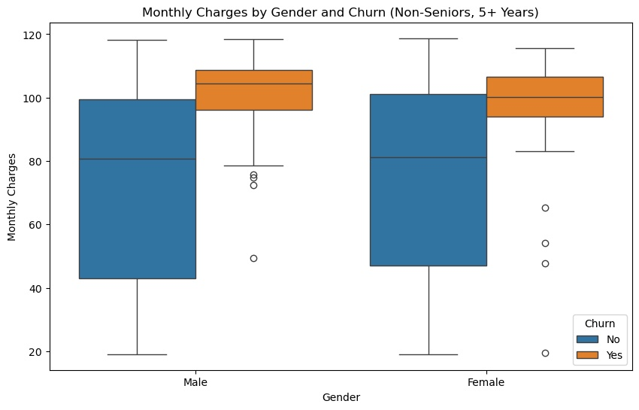

9.Churn Rate by Payment Method (Non-Seniors)
- Insight: Electronic Check has the highest churn rate (around 0.40), followed by Mailed Check (around 0.20). Bank Transfer and Credit Card (both automatic) have lower churn rates (around 0.15 each).
- Explanation: Customers using Electronic Check are more likely to churn, possibly due to payment issues or inconvenience. Mailed Check also shows higher churn, while automatic methods (Bank Transfer, Credit Card) retain customers better, likely due to ease of payment.
- Suggestion: Encourage switching to Bank Transfer or Credit Card with incentives like discounts. Improve the Electronic Check process to reduce payment-related churn.

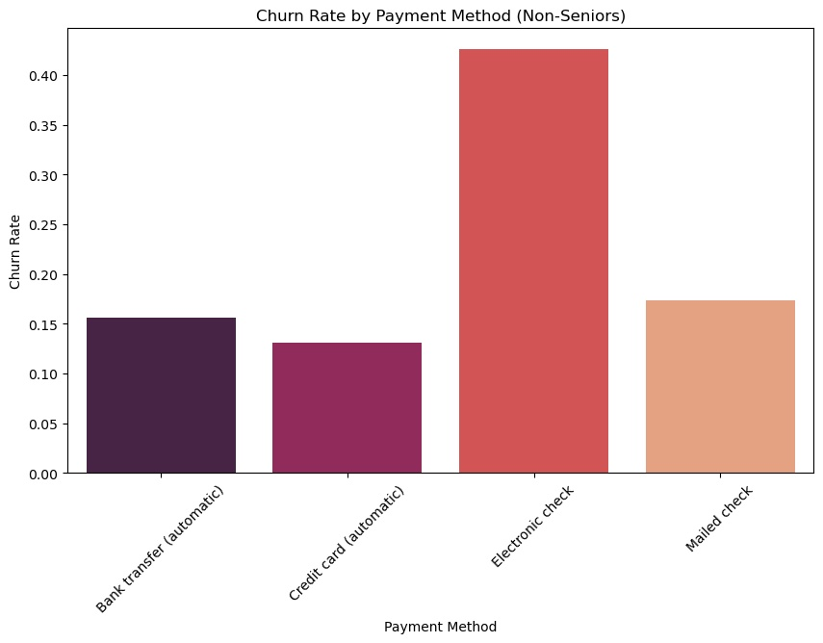

10.Activity Level by Gender (Non-Seniors)
- Insight: Females have around 400 moderate and 1000 normal activity customers. Males have around 400 moderate and 1000 normal activity customers, showing similar patterns.
- Explanation: Both genders have a majority of customers with normal activity (about 1000 each), with a smaller portion (around 400 each) showing moderate activity. This suggests activity levels are consistent across genders among non-seniors.
- Suggestion: Focus on engaging moderate activity customers with incentives to boost their usage. Maintain services that support the large normal activity group for both males and females.
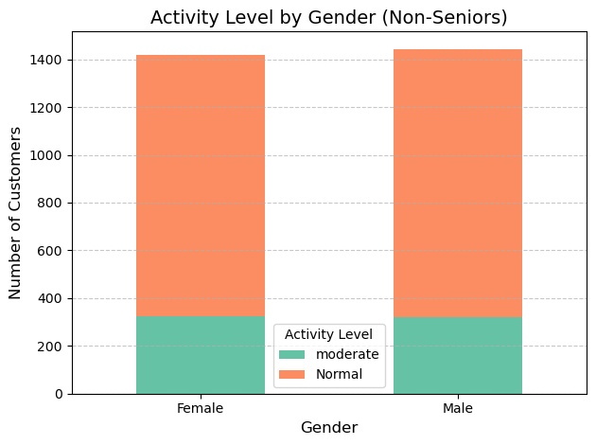
11.Activity Level by Tenure Group (Non-Seniors)
- Insight: The 0-1 year group has the highest number of customers (around 200 moderate, 600 normal). Numbers drop to around 300-400 total for 1-2 to 4-5 years (with 100-150 moderate, 200-250 normal), and 5+ years has about 500 total (150 moderate, 350 normal).
- Explanation: New customers (0-1 year) are most active, with a large normal activity group. Activity decreases with longer tenure, stabilizing at 5+ years, suggesting less engagement over time.
- Suggestion: Engage 0-1 year customers with incentives to maintain activity. Offer rewards for long-term customers (5+ years) to boost moderate activity levels.

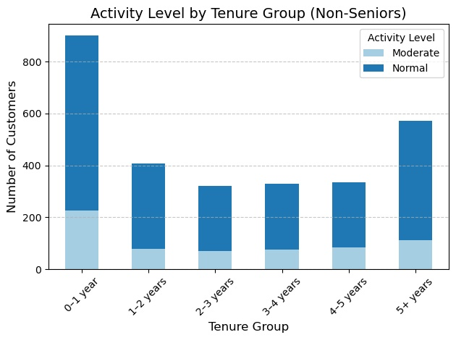

12.Average Calls Made and SMS Sent per User (Non-Seniors)
- Insight: Females average about 45 calls and 25 SMS. Males average about 45 calls and 25 SMS, showing similar usage patterns.
- Explanation: Both genders have a high average of calls (around 45) and a lower average of SMS (around 25), with no significant difference, indicating consistent communication habits among non-senior users.
- Suggestion: Promote SMS-based services or offers to boost SMS usage for both males and females. Ensure call quality remains high to support their primary communication method.

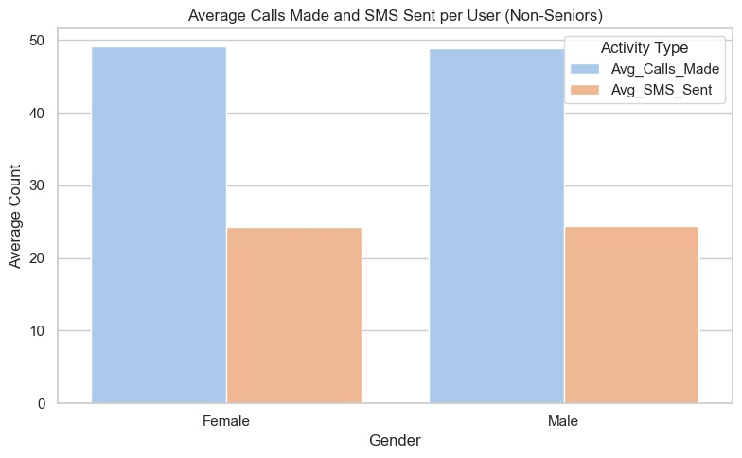

13.Non-Senior Users by Gender and State (Normal+Moderate Activity)
- Insight: Tamil Nadu has the highest count (around 60 females, 55 males), followed by Andhra Pradesh and West Bengal (around 50-55 for both genders). States like Nagaland and Mizoram have the lowest (around 30-35 for both genders).
- Explanation: Tamil Nadu leads in non-senior users with normal+moderate activity, showing strong engagement. Gender differences are minimal across states, with females slightly higher in some (e.g., Tamil Nadu), while male and female counts are balanced overall. Smaller states like Nagaland show lower usage.
- Suggestion: Focus marketing efforts in high-activity states like Tamil Nadu with gender-specific offers. Boost engagement in low-activity states like Nagaland with targeted promotions or improved services

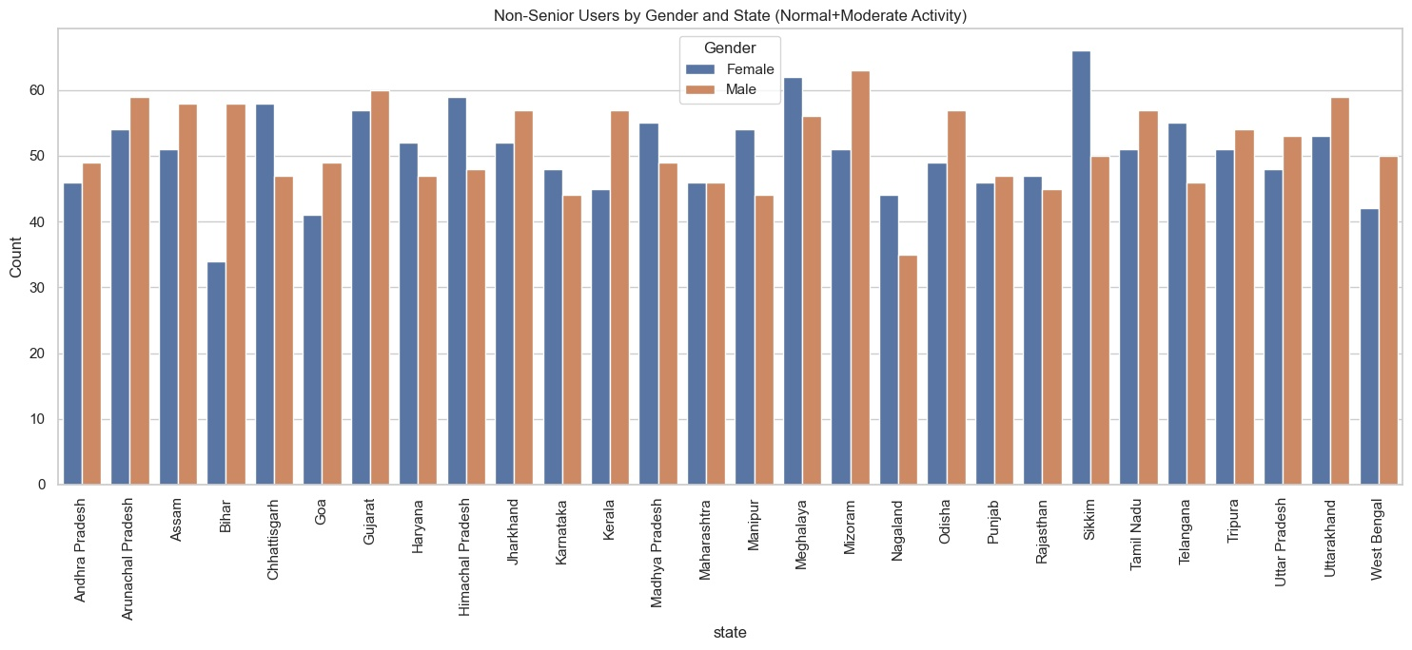

Graph Insights and Suggestions
14. Churn Rate by Tenure Group and Senior Citizen Status
- Graph Type: Box Plot
- Insight:
  - Highest churn occurs in 0–1 year tenure group for both senior and non-senior customers.
  - Seniors show more variability in churn behavior.

- Explanation:
  - New customers may leave due to unmet expectations.
  - Seniors may struggle with service complexity.
- Suggestions:
  - Implement strong onboarding for new users (e.g., tutorials, welcome gifts).
Offer simplified guides and senior-specific support

